ÔN TÂP TOÁN 6
Câu 1 Cho hai tập hợp A và B như sau:
A= {4; 6; 8; 10; 12; 14}
B=
- Cho biết số phần tử của tập hợp A và tập hợp B.
b) Dùng kí hiệu “” điền vào ô vuông:
6 A; {6} B; 16 B ; A B
c) Viết tập hợp B bằng cách chỉ ra tính chât đặc trưng cña tËp hîp.
B = {............................................}
Câu 2
a/ Phát biểu quy tắc cộng hai số nguyên âm.
b/ Vận dụng tính : (-12) + (-8)
Câu 3 Thực hiện các phép tính.
a) 81+ 243 + 19 b) 28.76 + 24.28
c) 4.5²- 3.2² d) 200:
Câu 4
- Tìm số tự nhiên x biết:
a).3 = 60 b)= 3⁶: 3³
- 2^{x} = 2².2
- Tìm tổng tất cả các số nguyên x thỏa mãn : - 6 < x < 5
Câu 5
Có một số sách nếu xếp thành từng bó 12 quyển, 16 quyển, 18 quyển đều vừa đủ bó. Tính số sách đó biết rằng số sách trong khoảng từ 250 đến 300 quyển.
Câu 6
a/ Thế nào là ba điểm thẳng hàng?
b/ Áp dụng: Vẽ ba điểm A, B ,C thẳng hàng, cho biết điểm nào nằm giữa hai điểm còn lại?
Câu 7
Trên tia Ox vẽ ba điểm A, B, C sao cho OA = 4 cm ; OB = 6 cm ; OC = 8 cm.
a/ Tính độ dài các đoạn thẳng AB, BC.
b/ Điểm B có là trung điểm của đoạn thẳng AC không ? Vì sao?
BÀI TẬP VĂN 6
Câu 1: Viết đoạn văn ngắn (7-10 câu) nêu cảm nghĩ của em về nhân vật Dế Mèn có sử dụng ít nhất một phó từ, một phép so sánh.
Câu 2: Viết đoạn văn ngắn (7-10 câu) đóng vai nhân vật người anh trai trong văn bản “Bức tranh của em gái tôi” nêu lại suy nghĩ của bản thân khi đứng trước bức tranh em gái vẽ mình, sử dụng ít nhất một phó từ , một phép so sánh.

ÔN TẬP LÍ 6 – LẦN 3
I/ Khoanh tròn trước chữ cái của câu trả lời đúng:
1. Hiện tượng nào sau đây sẽ xảy ra nung nóng một vật rắn?
A. Khối lượng của vật tăng. B. Khối lượng của vật giảm.
C. Khối lượng riêng của vật tăng. D. Khối lượng riêng của vật giảm.
2. Một lọ thuỷ tinh được đậy bằng nút thuỷ tinh. Nút bị kẹt. Hỏi phải mở nút bằng cách nào trong các cách sau đây?
A.Hơ nóng nút. B. Hơ nóng cổ lọ.
C. Hơ nóng cả nút và cổ lọ. D. Hơ nóng đáy lọ.
3. Khi làm lạnh một lượng chất rắn thì xảy ra hiện tượng nào dưới đây?
A. Khối lượng riêng của rắn lỏng tăng B. Thể tích của chất lỏng tăng
C. Trọng lượng của chất lỏng tăng D. Tất cả đều đúng.
4. Muốn đứng ở dưới để kéo một vật lên cao thì nên dùng hệ thống ròng rọc nào dưới đây?
A. Một ròng rọc cố định B. Một ròng rọc động
C. Hai ròng rọc cố định D. Một ròng rọc cố định và một ròng rọc động
5. Khi nhiệt độ thay đổi, các trụ bê tông cốt thép không bị nứt vì:
A.Bê tông và thép không nở vì nhiệt B. Bê tông nở vì nhiệt nhiều hơn thép
C. Bê tông nở vì nhiệt ít hơn thép D. Bê tông và thép nở vì nhiệt như nhau
6. Dùng tay ép hai đầu lò xo bút bi lại. Lực mà lò xo tác dụng lên tay ta gọi là gì?
A. lực hút B. Lực đàn hồi
C. lực đẩy D. Trọng lực
II. Tự luận :
1: Điền từ thích hợp vào chỗ trống .
- Thể tích không khí……....khi không khí nóng lên.b.
- Muốn nâng đầu một cây gỗ nặng lên cao 10cm để kê 1 hòn gạch xuống phía dưới thì phải dùng…………….
2. Ở đầu cán (chuôi) dao, liềm bằng gỗ, thường có một đai bằng sắt gọi là cái khâu dùng để giữ chặt lưỡi dao, liềm. Tại sao khi lắp khâu người thợ rèn phải nung nóng khâu rồi mới tra vào cán?
Trả lời: vì khi được nung nóng, khâu .........................giúp tra khâu vào cán............. và khi nguội đi khâu ......................giúp.......................lưỡi vào cán.
3. Một quả cầu bằng nhôm bị kẹt vào vòng bằng sắt. Để tách ra khỏi vòng, HS đem hơ nóng cả quả cầu và vòng. Hỏi bạn đó có tách được quả cầu ra khỏi vòng không?
Trả lời:
............................, Vì nhôm có sự nở vì nhiệt..........................đồng. Nên............................
4. Tại sao đổ nước nóng vào cốc bằng thuỷ tinh chịu lửa, thì cốc không bị vỡ, còn đổ nước nóng vào cốc thuỷ tinh thường thì cốc dễ bị vỡ? ( tham khảo sách bài tập trang 57 bài 18.3)
Trả lời: Vì thuỷ tinh chịu lửa nở vì nhiệt ...................... thuỷ tinh thường tới .
BÀI TẬP TIẾNG ANH 6
UNIT 5. NATURAL WONDERS OF THE WORLD
A. PHONETICS
a. Read the following pairs of words; pay attention to the underlines parts of the words you read.
1. Stop/ top | 6. best/ bet
2. Stable/ table | 7. boast/ boat
3. Stall/ tall | 8. lost/ lot
4. Plaster/ plater | 9. boost/ boot
5. Thirsty/thirty | 10. least/ leat
b. Fill each blank with a suitable word in Exercise to complete the sentences, and then read them aloud.
1. To join the army, you must be at .......................... eighteen years old.
2. I’m so ......................Would you please get me a drink?
3. A strong gust of wind blows down trees on the ............. of the mountain.
4. Where is my left ...............? Do you see it anywhere?
5. The teacher is sitting at the ................ .
6. Nam learns the ........................... in our class.
7. Oh, I’ve cut my finger. Will you give me a ............?
8. Remember to bring the compass if you don’t want to be ............. in the forest,
9. My mother often goes to the fruit............ to buy apples and oranges.
10. There is a ............... racing on the river every day.
c. Find the word which has a different sound in the part underlines. Read the words aloud.
1. A. desert B. visit C. island D. cheese
2. A. cave B. famous C. late D. valley
3. A. wonder B. forest C. welcome D. color
4. A. weather B. speak C. beach D. easy
5. A. windsurfing B. thrilling C. diverse D. cuisine
B. VOCABULARY & GRAMMAR
- Find the odd A, B, C or D
1. A. sleeping bag B. sun cream C. backpack D. eraser
2. A. weightlifter B. tennis C. volleyball D. soccer
3. A. visit B. walk C. map D. cross
4. A. highest B. hotter C. longest D. nicest
5. A. river B. lake C. mountain D. stream
- Put the verbs in brackets in the correct tense form.
1. Mrs. Mai usually (finish) ____________ her work at 5p.m.
2. Where (be) ____________ your children?
3. They (watch) ____________ TV in the sitting room.
4. In England the sun (not shine) ____________ every day.
5. Viet Nam (have) ____________ many beautiful beaches.
6. Look! Lan (wear) ____________ a new dress.
7. Don’t forget (send) ____________ me a postcard when you are holiday.
8. ____________ You (enjoy) ____________ collecting stamps?
9. What are you doing tonight?
10. I (go) ____________ to the circus. I like (watch) ____________ the performing animals.
c. Fill in the blanks with MUST or MUSN’T
1. She is ill, so she ____________ see the doctor.
2. It is raining. You ____________ take your umbrella.
3. You ____________ throw litter on the stairs.
4. This is a secret. You ____________ tell anybody.
5. You ____________ make noise in the library.
6. We ____________ hurry or we will miss the bus.
7. You ____________ eat fruit and vegetables.
8. The baby is sleeping. You ____________ shout.
9. You ____________ be friendly to everybody.
10. You ____________ walk on the grass in the park.
d. Comparative- Superlative Quiz.
1. which girl is ____________ Dana or Karen?
A. young B. the youngest C. Younger D. more young.
2. Tom is ____________ boy in the class.
A. the strongest B. more long C. strong D. the most strong.
3. The Great Wall of China is ____________ wall in the world.
A. the longest B. more long C. longer D. long
4. February is ____________ than April.
A. Short B. the shortest C. shorter D. more short
5. I am ____________ at music than my sister.
A. good B. better C. goodest D. The best
6. Hoa is ____________ girl in the class.
A. the cleverest B. clever C. cleverer D. more clever
7. Swimming is ____________ than running.
A. exciting B. more exciting C. excited D. the most exciting
8. Travelling by plane is ____________ than travelling by ship
A. fastest B. fast C. faster D. more fast
9. Jerualem is ____________ city in Israel.
A. the biggest B. big C. bigger D. biggest
10. The weather this week is ____________ than last week
A. bader B. bad C. the worst D. worse
C. READING
a. Read the passage and do the tasks followed
FANSIPAN MOUNTAIN
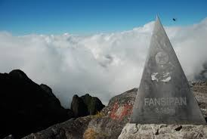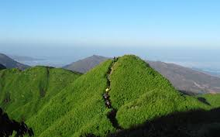
Fansipan is a mountain in Vietnam. At 3,143 metres (10,312 ft), it is the highest mountain in Indochina. It is located in the Lao Cai Province in the Northwest Vietnam, 9 km southwest of Sa Pa Township in the Hoang Lien Son mountain range. Due to its high elevation, Fansipan is called "the Roof of Indochina". With about 2,024 floral varieties and 327 faunal species, it is to be approves as one of the very few ecotourism spots of Viet Nam. You can climb through the trails to the peak of the mountain and observe the sunset. The best time to travel is between October and March when wild flowers are in bloom. Fansipan Mountain has long been the destination for those who are fond of exploring.
- Fill the table with the right information about Fansipan Mountain
1. Height:
2. Location:
3. Its another name:
4. Reason for the name:
5. The best time to travel:
6. Total of floral species:
7. Total of faunal species:
8. Things travelers can do:

- True or False? Check √ the boxes. Then correct the false statemnets.
 | T | F
1. Mount Fansipan is in the Northeast Viet Nam
2. It is one of the most famous ecotourism spots in Viet Nam
3. It attracts adventurous people.
4. It is the highest mountain in the world.
5. It is famous for its height.
6. Travelers can have a good time there.
7. Between October and March is the best time to travel.
8. It has long been destination for all people.
b. Phong Nha – Ke Bang National Park
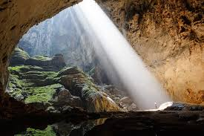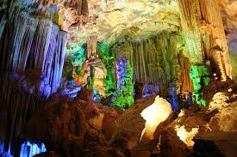
Phong Nha – Ke Bang National Park is a UNESCO World Heritage Site, located in the Bo Trach and Minh Hoa Districts of central Quang Binh province, in North central Viet Nam. Phong Nha – Ke Bang is famous for its cave systems. It has 300 caves with a total length of about 70 km, of which only 20 have been surveyed by Vietnamese and British scientists. The Park contains many fascinating rock formations and Ke Bang Forest. Travelers should take a boat ride through underground rivers to experience nature and enjoy fresh air.
* Answer the questions:
1. Where is Phong Nha – Ke Bang?
_________________________________________________________________
2. What is it famous for?
_________________________________________________________________
3. What should travelers do when they travel there?
_________________________________________________________________
4. How many caves are there in Phong Nha – Ke Bang?
_________________________________________________________________
5. Have Vietnamese and British scientists surveyed all the caves there?
_________________________________________________________________
6. Do you want to travel to Phong Nha – Ke Bang National Park? Why or why not?
* Complete the sentences:
1. Phong Nha – Ke Bang National Park………………………… site.
2. It is in …………………………………………………………………..
3. It is famous because……………………………………………………
4. There are………………………………………Phong Nha – Ke Bang.
5. Vietnamese and Britíh scientist ………………… only a few…………
6. The park also has many………………………………………………..
c. choose the correct word A,B, C or D for each gap to complete the following passage.
One of the (1)………. waterfall in the whole world lies on the Zimbezi River, which (2)……….. the border between Zambia and Zimbabwe. Some people think it is one of the most beautiful sights (3)………….. the world. Upstream, the river (4)……… through a wide valley. You could probably (5)………….. Victoria Fall from 25 to 40 miles away and see its spray rising 1,0000 feet into the air (6)…………… seven miles away. Long before you even see the waterfalls you can (7)……………….. the roaring of the water. Victoria Falls was (8)…………… by David Livingstone in 1855. The falls were names in honor of Queen Victoria. There is no doubt that Victoria Falls is a Wonder of The Natural World.
1. A. great B. greatest C. greater
2. A. form B. to form C. forms
3. A. in B. on C. over
4. A. runs B. flows C. flowed
5. A. see B. saw C. seen
6. A. got B. from C. of
7. A. touch B. hear C. watch
8. A. discover B. discovering C. discovered
* Answer the questions
1. Does Victoria Falls lie on the Zimbezi River?
_________________________________________________________________
2. Where does the Zimbezi River flow upstream?
_________________________________________________________________
3. What do some people think about Victoria Falls?
_________________________________________________________________
4. Can people see Victoria Falls?
_________________________________________________________________
5. Who discovered Victoria Falls?
_________________________________________________________________
6. Why were the falls named Victoria?
_________________________________________________________________
D. WRITING
a. Make sentences using the words and phrases given
1. June/ hot/ May/ but/ July/ the/ hot.
_________________________________________________________________
2. Students/ must/ keep/ school/ clean/ beautiful.
_________________________________________________________________
3. Remember/ bring/ essential/ travel items/ your holiday/.
_________________________________________________________________
4. Mr.Phong/ want/ explore/ coast/ boast/.
_________________________________________________________________
5. I/ think/ Nha Trang/ the nicest/ beaches/ visit/.
_________________________________________________________________
6.What/ weather/ like/ Sapa?/
_________________________________________________________________
7. The Han River/ flow/ throw/ Da Nang city/.
_________________________________________________________________
8. We/ mustn’t/ drive/ the left/ Viet Nam/.
_________________________________________________________________
9. who/ the strongest/ your/ family?/
_________________________________________________________________
10. There/ not/ many/ trees/ my neighbourhood/.
_________________________________________________________________

b. Rewrite the following sentences. Beginning as shown, so that the meaning stays the same.
1. There are lots of beautiful lakes in Viet Nam.
Viet Nam………………………………………………………………..
2. Many tourists want to visit Sa Pa because of its fresh air.
Many tourists want to visit Sa Pa because……………………………….
3. Da Nang is smaller than Ha Noi, and Ha Noi is smaller than Ho Chi Minh city.
Ho Chi Minh city.…………………………………………………….…
4. Our country doesn’t have any deserts.
There.…………………………………………………………….……….
5. No one in our class is taller than Vinh.
Vinh..……………………………………………………………….……….
6. Watching TV is more interesting than reading books.
Reading books.………………………………………………………….……
7. My home village lies near the foot of mountain.
My home village.……………………………………………………….………
8. Mr Hung is Nam’s teacher.
Nam is.……………………………………………………………..………….
9. Remember to do your homework.
You must………………………………………………………………………
10. Quang sits in front of Minh
Minh sits…………………………………………………………………..……

c. Imagine you are a tourist on vacation in a certain place in Viet Nam or in a foreign country where there are natural wonders. Write a postcard to a friend about your trip. You need to cover the information about:
- Place: name of the place you visit: Sa Pa, Da Lat, etc..
- How you feel about the people: friendly, hospitable, helpful, etc…
- What the weather is like: warm, cold, sunny, windy, etc…
- Who you meet/see: old friends, relatives, neighbours, etc…
- Write about the things and people of the place you visit with other places.
- What you buy: postcard, souvenirs, books, ect….

UNIT 6: OUR TET HOLIDAY
- PHONETICS
- Find the word which has a different sound in the part underlined. Read the words aloud
- A. home B. pagoda C. clothes D. flower
- A. visit B. like C. city D. wish
- A. relative B. decorate C. present D. prepare
- A. plant B. chat C. make D. family
- A. celebrate B. come C. cook D. cousin
b. Practise saying the following sentences with a focus on the underlined words.
1. Can you show me the way to the city centre?
2. What should you do to celebrate Tet?
3. We should clean and decorate the house.
4. We shouldn’t drink too much wine.
5. We should make a wish when Tet comes.
B. VOCABULARY AND GRAMMAR
a. Circle A, B, C or D for each picture
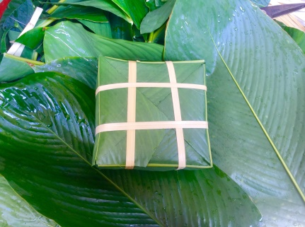  1. A. banh chung  B. banh tet  C. banh day  D. banh bao | 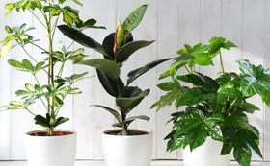  2. A. lucky money  B. balloons  C. firecrackers  D. plants | 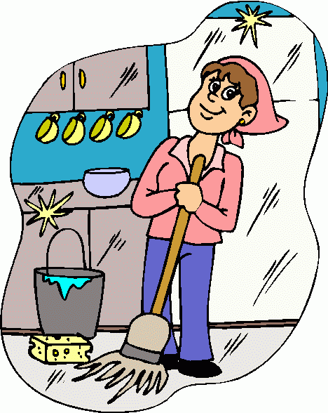  3. A. swimming pool  B. decorating house  C. cleaning house  D. painting house
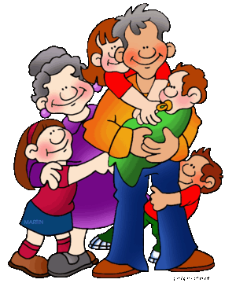  4. A. visiting grandparents  B. sleeping with grandparents  C. shopping with grandparents  D. tidying up with grandparents |  | 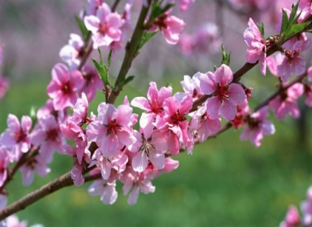  5. A. lucky money  B. new clothes  C. peach blossom  D. family gathering

b. Find a word to complete the following sentences
1. We always ____________ our grandparents and our relatives on the first day of Tet.
2. I ____________ our grandparents good health and a long life.
3. Our grandparents often give us good advice and ____________ money when we visit them at Tet.
4. My sister and I always wear ____________ clothes at Tet.
5. There are many beautiful ____________ in our garden at Tet. They are really colourful.
6. My friend likes ____________ banh chung and spring rolls (nem) at Tet.
7. I often go ____________ with my mother before Tet.
8. When spring comes, the students in my school often plant a lot of ____________ in our school garden.
9. At New Year’s Eve, I usually go to Hoan Kiem Lake to ____________ firecrackers with my parents.
10. I wish this New Year everyone will ____________ a job and enough food.
c. What should/ shouldn’t you do at Tet? Complete the sentences.
1. You ____________ buy firecrackers.
2. You ____________ clean and decorate your house.
3. You _______________ eat too much sweets.
4. You _______________ wish all the people you know “Happy New Year”.
5. You _______________ help your mother with cooking.
6. You _______________ quarrel with each other.
7. You _______________ go to a pagoda to pray for good health and good luck.
8. You _______________ play cards for money.
9. You _______________ stay up late.
10. You _______________ watch too much TV.
d. Choose the correct answer A,B,C or D to complete the sentences.
1. My mother is a good cook. She often_______ special food at Tet.
A. buys B. cooks C. takes D. brings
2. Did you like to _______ banh chung at Tet?
A. know B. eat C. help D. do
3. People often _______ red envelopes for lucky money at Tet.
A. bring B. take C. buy D. ask
4. Before Tet, people often give _______ to show their love and respect.
A. firecrackers B. plants C. food D. presents
5. Tet is a time for family _______
A. working B. cooking C. playing D. gathering
C. READING
a. Read the passage about Lunar New Year (Tet) in Viet Nam, then answer the following questions.
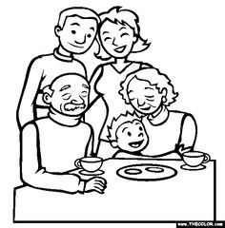
Lunar New Year iss one of the festivals celebrated in some Asian countries. It is the greatest Vietnamese festival. It is called Tet in Viet Nam. It usually takes place between the end of January and the beginning of February.
Celebrations begin with the family reunion dinner which is held on the New Year’s Eve. Every member of the family is eager to attend this family feast. The feast usually consists of banh chung or banh tet, spring rolls, chicken and some other special food.
The children usually wear clothes and go with their parents to visit their grandparents and relatives. The children say “Happy New Year” to all the people they visit and are often given lucky money in red envelopes. They are very happy.
- When does the Lunar New Year take place?
______________________________________________________________
- When do the Vietnamese hold their family reunion dinner?
______________________________________________________________
- What do the Vietnamese children usually do at Tet?
______________________________________________________________
- What are the children often given at Tet?
______________________________________________________________
- How do the children feel?
______________________________________________________________
b. Read the passage and decide if the statements are true (T) or false (F).

A few days before Tet comes, my family has much work to do. My mother begins cleaning and decorating the house. My father and I help her. We tidy up the house until it is spick and span. Our house is so neat and tidy. The decoration looks lovely.
During Tet, I help my mother to serve food and drinks when our relatives or friends visit us. I feel proud of myself to help my parents.

 | T | F
1. A few days before Tet comes, the family does a lot of work.
2. They don’t decorate the house
3. The writer help the mother to cook the meal.
4. The family invites the guests to have food and drinks when they come.
5. The writer feels tired to help the parents
c. Read the passages above again and complete the sentences with the words given.
reunion | tidy | lucky money | decorate | festival
- Tet is the greatest ___________ in Viet Nam.
- Before Tet, people often clean and ___________ their house.
- Family ___________ dinner is held on the New Year’s Eve.
- At Tet, all houses look neat and ___________
- Children are often given___________ in red envelopes.
D. Writing
a. Write true sentences about New Year practices in different countries, using the words/ phrases given.
1. the USA/ when the clock/ strike/ midnight/ ,/ everybody/ cheering/ and/ singing/ happily.
2. getting up/ on/ the first day/ of the New Year/ ,/ the Chinese children/ dress/ beautifully/ red.
3. every Vietnamese family/ buy or cook/ banh chung or banh tet/ Tet
4. Japanese people/ believe/ ringing bells/ can/ remove/ their bad actions/ previous year.
5. the Scottish/ believe/ the first footer/ the New Year’s day/ decides/ the family’s luck/ the rest/ the year.
b. Fill in each gap of the letter with will or won’t
Dear Mary,
How are you?
I am very glad because Tet is coming.
It’s our New Year celebration.
Before Tet, I (1) ___________help my family with the house decorations. I (2) ___________ go to the flower market with my mother and my sister. We (3)
___________ a peach blossom tree and some flowers. Then, my mother (4)
___________ buy some new clothes for us. We (5) ___________ buy some sweets, some coffee and some tea but we (6) ___________ buy cigarettes. My father gave up smoking. We (7) ___________ make spring rolls and I like it. We (8) ___________cook banh tet. They are really delicious. I (9) __________ visit my grandparents and my relatives with my parents. The thing I like best is I (10) ___________ have to do my homework at Tet. I have a lot of time to relax.
Write to me.
Mai
c. Now write your own letter to your pen friend telling him/her about Tet holiday. Use the idea above.
Dear……….
______________________________________________________________
______________________________________________________________
______________________________________________________________
______________________________________________________________
______________________________________________________________
______________________________________________________________
______________________________________________________________
______________________________________________________________
______________________________________________________________
______________________________________________________________
______________________________________________________________

